Gazette
IN THIS ISSUE:
SCHOOL AND PRESCHOOL NEWS p4-6 and 8
Dunoon and District
$0.00 Whinge Free (Mostly)
Issue No 166 April – May 2018 www. dunoongazette.com

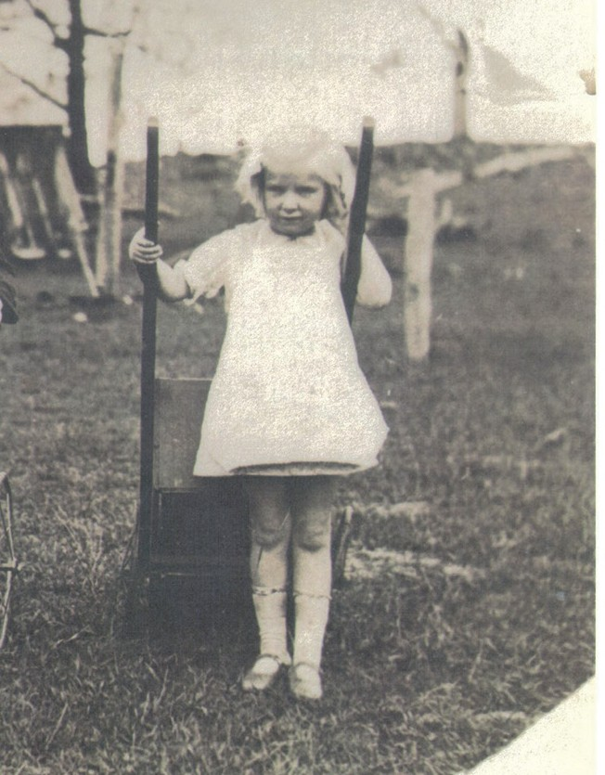

HISTORY p3 & p7
ARTS & EVENTS p10
CLUB NEWS p12-13

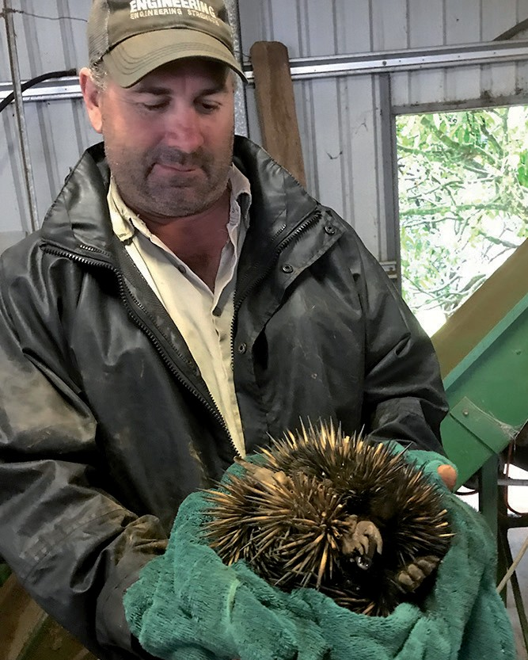

WIRES NEWS p19
DUNOON AND DISTRICT GAZETTE April – May 2018 1
CHURCH NEWS p9 & 18
CISARUA REFUGEES p20-21

GAZETTE ADVERTISING RATES
B
1 issue
(2 months)
Small (30mm H x 60mm W)
$19.00
Regular (70mm H x 60mm W)
$29.00
3 issues
6 issues
(6 months) (1 year)
A
$51.00
$93.00
$75.00
$145.00
- Medium (100mm H x 60mm W)
$38.00 $102.00 $185.00
- Large Strip (65mm H x 195mm W)
$59.00 $165.00 $292.00
- Small Strip (30mm H x 195mm W)
$44.00 $121.00 $220.00
- Half Page (135mm H x 195mm W)
$83.00
Full Page (270mm H x 195 W)
$132.00
2 X Full Pages – 10% discount
$220.00
$413.00
G
$352.00
$660.00
H
Business Directory listing $11 for 6 issues or free with display ad.
GDunoon aand Disztrict ette
All editorial or advertising copy and images to be emailed to editor@dunoongazette.com or hard copy left at/posted to:
Dunoon Post Office,
James St, Dunoon 2480
marked Attention Gazette Editor. Please supply images as a high resolution .jpg file by e-mail, disc or USB stick. Please ensure you have copyright permission for materials supplied.

Editor: Bronwen Campbell
(H) 02 6689 5902
(M) 0439 842 237
Advertising and Accounts: Leane Kalnins
Website: Bronwen Campbell

Next Issue:
June – July 2018
Copy Deadline: May 21st
Thank you to all contributors,
distributors and advertisers
Classified ads, size A, $14 per issue – text only, no images.
Advertorials $39 for one issue or free with a booking of an ad size C – G for 3 or 6 issues.

It helps us tremendously if you pay on time BSB 062565, Account 10252012
The Dunoon And District Gazette is not-for-profit and is GST free

*Fridges *Dryers *Washing Machines *Dishwashers

RUSSELL’S

Same day in-house service
* Friendly & Professional Established over 60 years
* Full Mobile Service

Ph 6621 3992
ozwash2480@gmail.com Dunoon Lismore Alstonville Nimbin Clunes

A FEW WORDS FROM THE EDITOR...
G
ripping. Powerful. Intense. These are the words I used to describe opening night of
1932 at Ellangowan: Cameron twins Ronnie and Winnie and playmate Mervyn Allan
the latest Ballina Players play “A Few Good Men”. It was one of the best plays I have seen. There are only 4 more per- formances with the season finishing on April 15th, so get in and book your tickets! We are so lucky to have opportu- nities for such great theatre so close by.
Another event coming up this weekend is at NORPA – see the details on page
10. The musician and founder of Onyx Productions, Gene Petersen, is one of Lismore Shire’s great success stories – he grew up on a farm between Casino and Lismore and went to Trinity High

School.
In the Dec-Jan edition of the Gazette (Issue 164), I mentioned capturing the history of people in our families and in our local communities. Winnie David- son has given me a couple of photos for the Gazette from her own child- hood in the local region. Many of you probably know Winnie, or have seen her in her distinctive little yellow car around Dunoon. I’ve included one of the photos here, and hope to get a story to go with the other photo for the next issue of the Gazette.
Her picture reminded me of one I have of myself on a tricycle taken in the late sixties at my home in Mangere East, Auckland, New Zealand. Just for fun I have included it here – the photos may
be over 35 years apart, but they show how kids don’t really change! Perhaps more of our locals can give us a little of their history through either stories or pictures – if you have one of you, your siblings, or your parents on a tricycle, send it in to get the ball rolling!
On the subject of history, there is a call for assistance with the Richmond River Historical Society on page 7. WIRES needs some volunteers and have some great stories about wildlife, including local Dunoon stories on page 19. The RFS is in need of new members – see page 11. We also have our usual school, preschool and church news on pages 9 and 18.
There is a focus on health on page 16 with an opportunity to join in a study aimed to help people quit smoking. You can also register to host a morning tea for Cancer Council’s Australia’s Biggest Morning Tea event. I will host again this year, so please feel free to come along. I am tentatively plan- ning to hold it on Monday June 11th at 11:00 am, but please call me on 0439 842 237 to RSVP closer to the date as I have a few unknowns in my calendar in the coming months that may cause me to postpone. Holidays are a great way to stay mentally healthy, so you might enjoy reading about Annabelle’s holiday on page 7 or book a cruise of your own with Schirelle (p 16). Perhaps you could go to Port Macquarie to the lovely apartment advertised on this
page.
Other articles include Landcare, Papua New Guinea, and a sobering reflection on the plight of refugees in Cisarua, In- donesia on pages 20-21.
The winter season of football has started, so plenty of opportunity for watching football from the Deck of the Club, enjoying the lovely restaurant and bar or cafe food and coffee. Other club news is on pages 12-13.
Enjoy this edition. Until next time.
Bronwen Campbell
LUXURY 3 BED/2 BATH APARTMENT WITH LARGE BALCONY OVERLOOKING THE PACIFIC OCEAN AND HASTINGS RIVER IN PORT MACQUARIE.
THE UNIT HAS A NORTHERLY ASPECT AND IS CENTRALLY LOCATED IN CBD JUST A 5 MINUTE STROLL TO THE SHOPS, BARS AND RESTAURANTS
FOR MORE INFORMATION GO TO WEBSITE OR CALL DIANNE FLYNN O408614113
http://wiseberry.com.au/ portmacquarie/listing/port- macquarie/17-3-munster-street- apartment-unit/261761994

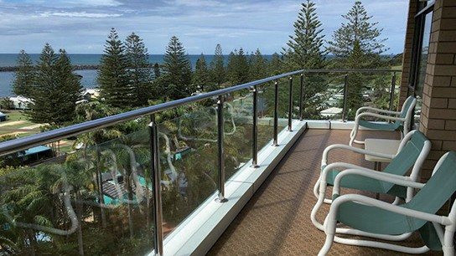

DUNOON PUBLIC SCHOOL NEWS
G

reetings from Dunoon Public School! It has been a wonderful start to the year
for our beautiful school with lots happening in and out of the classrooms.
New Beginnings
This time of year always heralds a new beginning for our Kindergarten students. This year we have welcomed 13 eager young people into our school commu-
nity, and they have made an amazing start to their school journey!
Our Kinders have individual learning goals, which they are all busily working towards.

Swimming Carnival
We saw an outstanding effort by all of our students at the Dunoon District Swimming Carnival! Standout performances were champions Philippa and Darcy and runner up, Iris. Many students went on to represent the district at the zone carnival.

Year 5/6 Water Quality Day and Camp
Year 5/6 had a fabulous day at Dorroughby Environmental Education Centre learning all about water quality. The students learnt about the impacts

Would you like to operate your own business from home
and receive free training & support?
Educators urgently required in the Dunoon area
Family Day Care Educators can earn an hourly rate of
$33.60 (caring for 4 children), plus another $19.50 p/h caring for 3 school children, all from the comfort and convenience of your own home. • Flexible hours • CCB & CCR approved •Before & After School Care and Vacation Care • A safe, loving & stimulating home environment • Assessed as EXCEEDING National Quality Standards.

Northern Rivers Family Day Care

High Quality Childcare in a Family Home Environment

For more information about placing your children in care, or about becoming a Family Day Care Educator or In Home Care Educator, please contact our office on lismore.admin@nrcs.org.au 6621 6437 www.nrcs.org.au

DUNOON PUBLIC SCHOOL NEWS continued
Check mate!
Four of our chess players represented the school at the Term 1 Gardiner Chess Tournament, held at Woodlawn College. Ben, Robert, Jack and Darius all played really well, and as a team they placed 2nd overall. Ben placed 3rd in the individual awards, winning 6 out of 7 games.

New Pedestrian Upgrade
We are very fortunate to now have a new footpath outside our school. Not only does it look great, it provides a safe area for students and parents to access the school.

of different land uses on the catchment (farming, forestry, urban development) and looked at solutions to help clean up our waterways. They then all had a sleepover at DEEC (and actually got some sleep!).

Hockey
In Term 1, students enjoyed a hockey program that covered the basic techniques and rules of hockey. Our visiting coach was most impressed with our students’ abilities!

3-6 Cyber bullying presentation
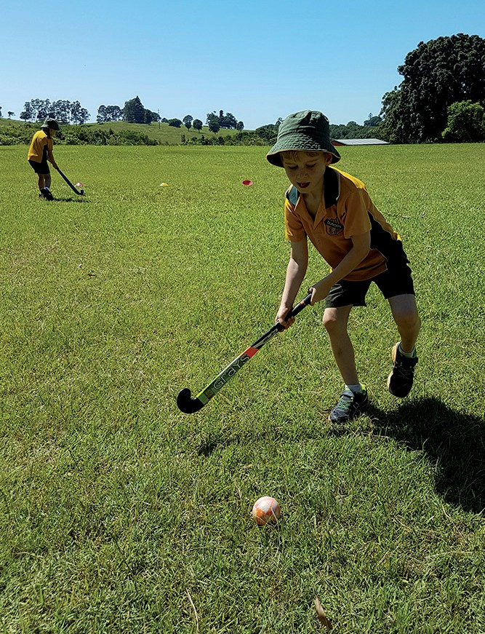March 16th was the National Day of Action Against Bullying and Violence. In support of this, students from Years 3 to 6 attended an online “virtual class” about cyber bullying. Dunoon Public School stands strong against any kind of bullying, whether it is verbal, social, cyber or physical. Our staff continue to support the well-being of all students in the school through the whole-school “Stop Walk Talk” program and through lessons, conversations and strategies
around bullying behaviour.
SELF PUBLISHED BOOKS
ALL-INCLUSIVE RATE INCLUDES:
- Initial consultation & preparation • Design & production of the book cover and text section • Free scanning & insertion of all photographs/illustrations
- Normal copy-editing, photo retouching & proofing
- Standard indexing in non-fiction books • ISBN & National Library Cataloguing-in-Publication Data
  - Quality Printing
- Saddle Stitching, Perfect & Wiro Binding
  - Environmentally Friendly Papers
    - Small & Large Print Runs

201 Union Street Lismore 2480
Tel. 02 6621 5371
Fax. 02 6622 1296
Lismore City Email. quotes@cityprint.com.au
PRINTERY www.cityprint.com.au

MODANVILLE PUBLIC SCHOOL NEWS WITH ERIN AZZOPARDI
I

t feels like we only just begun the new school year and it is almost time for school holidays! It has been
a busy term with lots going on as usual.
The new year begun with a successful parent information night and welcome BBQ. The new kindergarten students have settled in to school routines and are eager, enthusiastic learners. We are de- lighted at how well they have adjusted to the demands of the school environ- ment.
Our students have been enjoying a spe- cialist basketball teacher coming into the school on a weekly basis as part of the School Sporting Grants. The staff have also been learning new skills to implement in our school sports program.
This term we had students from years 2-6 compete at the Dunoon District Swimming Carnival, with many of our students qualifying to compete at the Zone Swimming Carnival. All of the students that participated made our school very proud.
Earlier this term a group of 5/6 students went to Lennox Head Public School to refine their debating skills. The students formed teams and debated against each other about whether children should be on the internet or not. Guess who won? Students thoroughly enjoyed the experi- ence and have learnt the importance of arguing eloquently.
Our 5/6 students also participated in
an excursion to our local high school,
Richmond River High School. The students enjoyed a range of activities such as woodwork, agriculture, music and many P.E ac- tivities. Our students reported that they loved making a can- dlestick holder.
Harmony Day was celebrated at our school with students filling out question- naires about their family’s cultural her- itage and identifying these different coun- tries with pushpins on a world map. The students, staff and parents that were present also made handprints that were cut out and created into our ‘Harmony
Tree’ which is on display in the school library. Stories of different cultures were read to the students; a favourite being ‘Mirror’ by Jeannie Baker.
As I write this article there is a buzz of excitement around the school as the students look forward to the Easter Hat Parade and the Easter Egg Raffle. If you have bought a raffle ticket for our Easter Egg Raffle, thank you for your support, and good luck!

The Easter Egg Raffle and the upcoming school disco are initiatives of our excel- lent Student Representative Council. All of our students and staff had the oppor- tunity to vote for responsible students from Years 2-6 to form our SRC. Con- gratulations to all the students who were elected. We think you are doing a great job of making our school a better place.
Erin Azzopardi

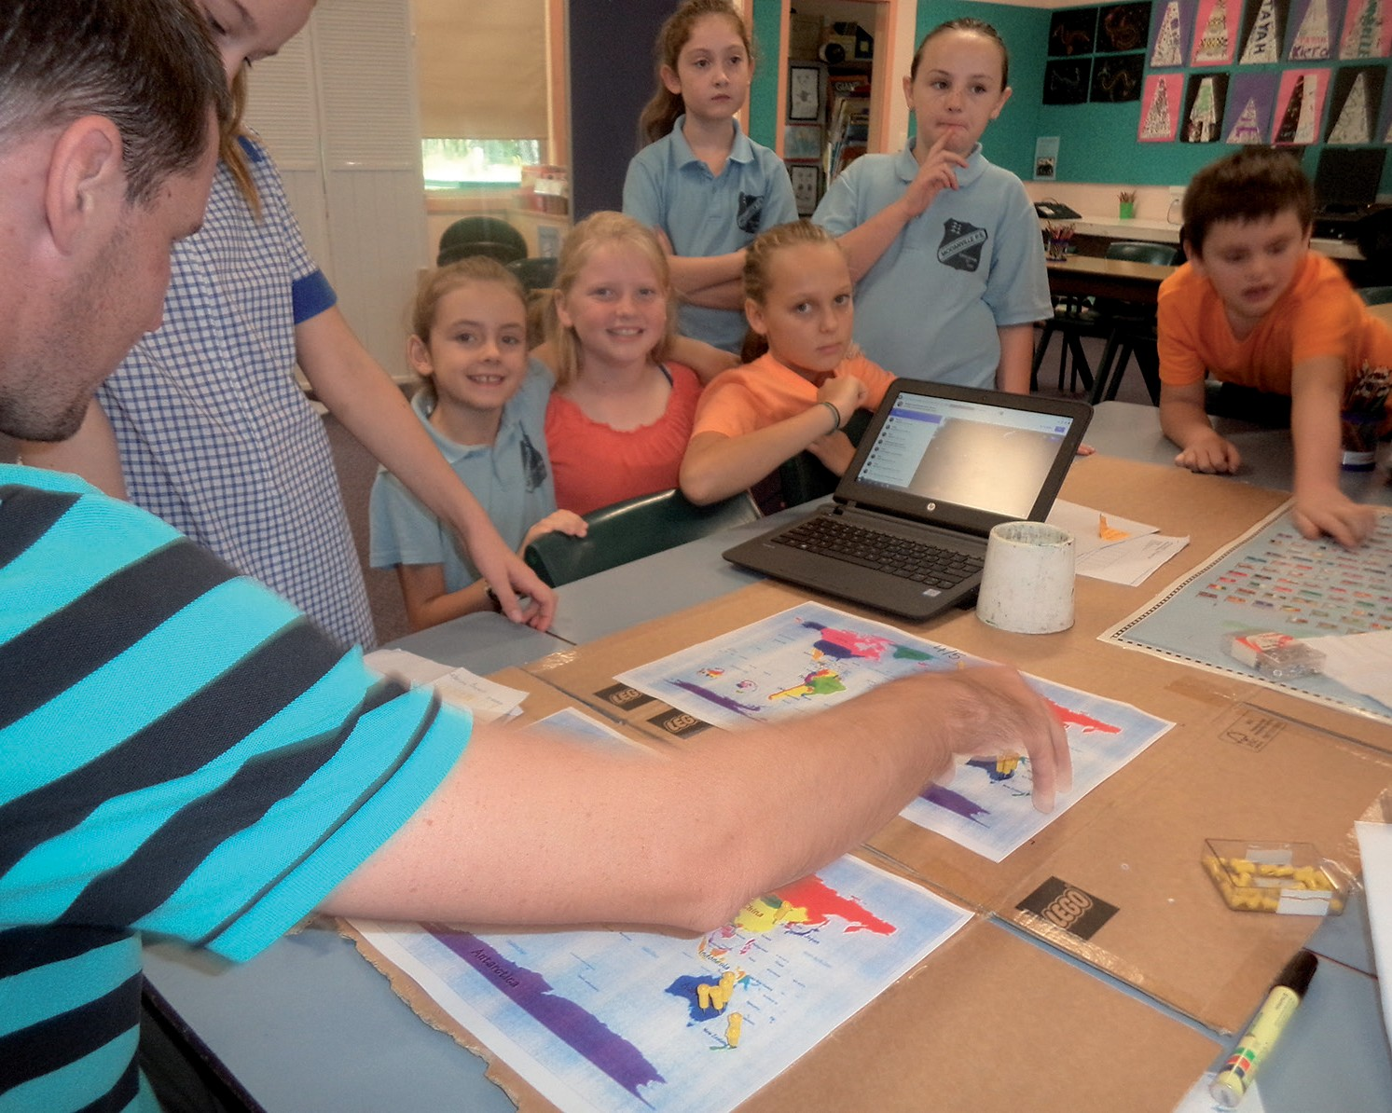

GREAT BARRIER REEF WITH ANNABELLE CROW

Cruising to the Great Barrier Reef brings awareness of need to protect it
I recently returned from a week long cruise to the Great Barrier Reef. One of the highlights of my holiday was going on an hour long flight over the Whit- sundays and out to the reef in a small plane. We flew over Hayman Island, Hamilton Island, Daydream Island, the 7km long Whitehaven Beach and many reefs, including the “Heart Reef”, so called because of its shape.

Whitehaven Beach and lagoon

Once we saw that, we began to see all all sorts of familiar shapes in the reefs which we started calling “the sunglass- es reef” and “the rocking horse reef”, etc. We were lucky that it was low tide and the whole reef was exposed.

I chose this particular cruise because I had never actually seen the reef except on television shows and there is the risk that the reef may not survive in its present state for much longer. Accord- ing to David Attenborough and marine geologist, Dr Robin Beeman, more than 50% of the reef’s coral has been lost in the last 30 years. When you consider that the reef was formed about 14,000 years ago that’s pretty scary. The Reef is the largest coral system in the world and is a World Heritage site. Why aren’t we doing a better job of protecting it?

The Heart Reef
Another excursion that was well worth going on was from Cairns up to Kuranda on the Atherton Tablelands. Although I had been to Kuranda 30 years or so ago, this trip was special because after exploring Kuranda I trav- elled on the historic Kuranda Railway back to Cairns, passing through tropical
rainforest reminiscent of the still intact parts of our local Nightcap rainforest and over narrow bridges and stunning gorges. As the train has been operat- ing since 1891 I swallowed my fear and put my faith in Queensland Rail. The Barron Falls (where the train stopped so we could take photos) and Stoney Peak Falls were stunning. It was impos- sible to fit the full height of the Barron Falls into one photo!
Annabelle Crow
Barron Falls

RICHMOND RIVER HISTORICAL SOCIETY WITH DENIS MATTHEWS

would like to write on behalf of the Richmond River Historical Society (RRHS)
I
I doubt that there is any reader of this Gazette who has absolutely no interest in the history of our district. There are surely many who would like my history of Dunoon to have told more about people than about land, but it was the ownership and occupation of land that attracted my interest in the first place. It was the RRHS that published my book and encouraged me to follow it through with access to the wonderful resources of its archives. Besides the whole story has not been told and maybe one of our readers is going to take up the chal- lenge of giving us a fuller version of our history.
The work of the RRHS depends on volunteers. The society engages some contractors but I do believe it has no employees whatever. Even the cleaner is a contractor. The society’s projects rely entirely on volunteers and there are never enough to do the work involved. I wonder how many of our readers are looking for a rewarding challenge to occupy their spare time. One can hardly find a more interesting challenge than the work of the Society, and there is need for a huge range of skills and in- terests.
Quite recently the museum was a busy space, but in just a few years the number of volunteers has become sadly depleted. My own involvement is acting as editor of the Bulletin which somehow contin-
ues to thrive thanks to a small number of contributors and to the pro bono contri- bution of a wonderfully talented graphic designer who normally works as a pro- fessional in the field. While the work of editor can be intense just four times a year I can usually find time to take an interest in some of the wonderful work my associates are doing. Some of them have a wonderful store of knowledge of the history of our district and are pre- pared to share that knowledge.
But please do not think one has to have the same degree of knowledge as these few to be useful in our Society. Anyone at all who has the desire to help can do great things for our Society. Please give the idea some consideration.
Denis Matthews

DUNOON PRESCHOOL NEWS WITH KATE SCANLAN
T

he start of 2018 at Dunoon Preschool has been lovely. We have met our new children and
their families and everyone is settling in and feeling happy. We are helping all preschoolers to feel comfortable about not having just one “best friend” but rather to include lots of people in their games and have many friends to play different games with at different times.
We had a great working bee in the middle of the term, with lots of handy parent helpers and a lovely little concert and bbq dinner.
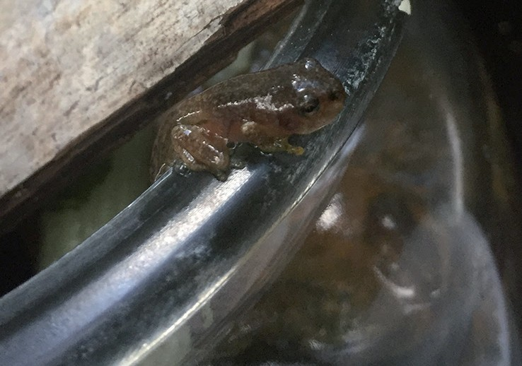
We are lucky enough to have some “pets” this term... we have had 3 sets of tadpoles to watch wriggle, eat and eat and eat and then get their back and front legs and finally get big enough to leave the water and hop away.

Our froglets

In the last 2 weeks we have caterpillars. The first lot had been affected by a wasp and so we saw a different “life cycle” to what we expected. The second set are progressing as expected – two are cur- rently in their chrysalis stage and we hope they will transform into butterflies just before the holidays!
Keeping with local wildlife.... we also had a visit from Lyn from Richmond Landcare who told the preschoolers all about our lovely native stingless bees that we have in our back garden. We hope to have our hive split and to taste the honey from the hive next term.
We had another lovely visit from Joanna to share a Yoga Story with us. This time there was a Harmony Day focus with the story of “Handa’s Surprise”. This year at Preschool we celebrated Harmony Day through sharing the joy and diversity of dances from around the world.
Before Easter we had our annual visit to Whian Whian School for their Easter Parade. We always love going on a real live bus (!!) and visiting this school – joining in with craft activities, singing and dancing and of course, an Easter egg hunt! Thanks Whian Whian!
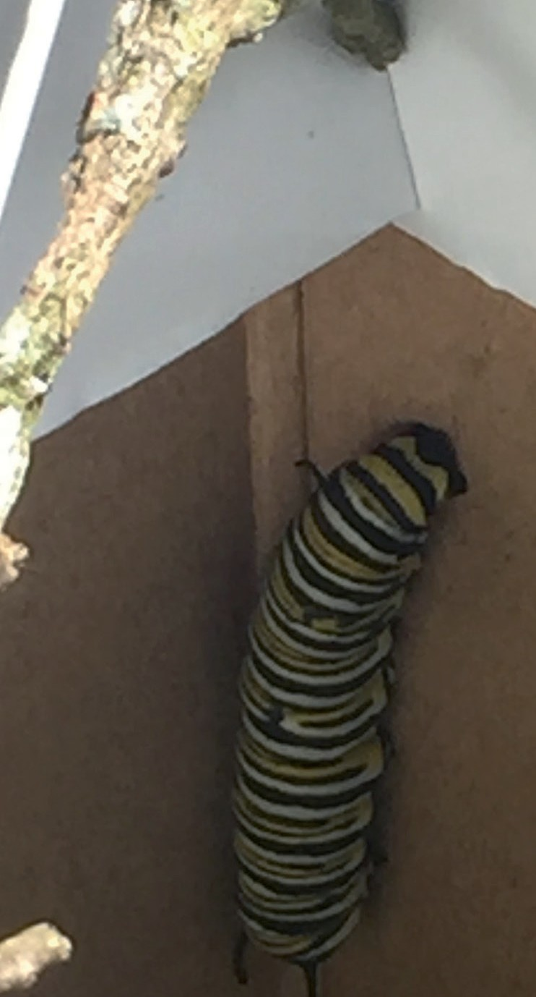
I write this as our Preschool is the Charity of the Day at the Channon Market. We are so lucky to have the op- portunity to be part of this great market and to have the support from the Pre- school Families to be able to run this es- sential fundraiser.

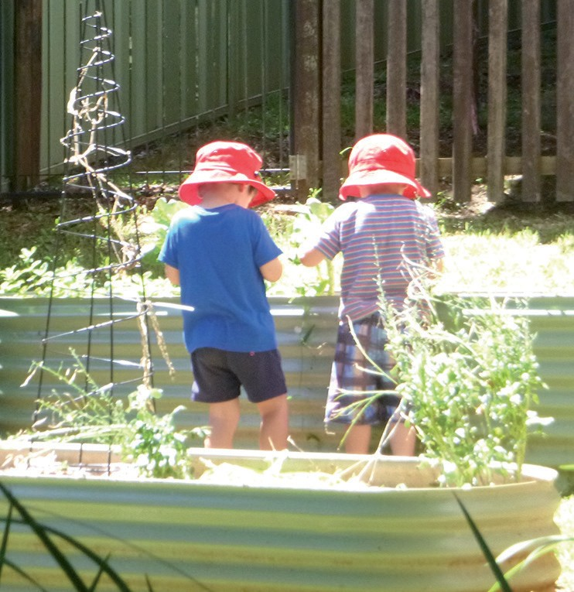
Friends snail hunting. Finding, caring and releasing snails has been a big part of our first term.

See you next term!!
Kate Scanlan
An amazing water colour artwork by a preschooler after a group time art technique session on water colours

Monarch Butterfy Caterpillars and chrysalis

ST DYMPNA’S CATHOLIC CHURCH NEWS WITH JENNIFER JULEFF

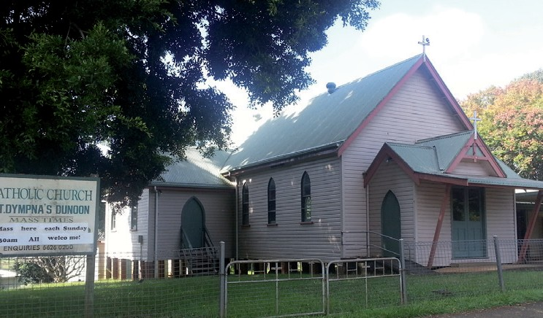
Saint Dympna's
Catholic Church has a time change –
now 8.30am every Sunday morning

t the moment we are preparing to give the inside of the Church a nice new coat of paint,
A
preparations are under way with the removal of our Holy statues, curtains and many other things that we hold close to our hearts. We are eagerly looking forward to the end result.
If you would like to join us we would very much welcome you into the fold. After Mass we sit and have a chat over a cuppa and lovely homemade cakes and any fresh fruit someone has picked from their trees.
We are hoping for a visit from our new Bishop Gregory and show him our lovely community and village.
Barbie, one of our devoted parishion- ers, goes out three times week and teaches Scripture in our local schools at Dunoon and Modanville then travels into Lismore. If you see her around the school make sure you say a big hello to her.

Phone: 6621 3000
Fax: 6621 7773
Conveniently located at
Shop 5/76 Woodlark Street,
Lismore
(at the carpark end of the walkway next to the ANZ bank)
Ask us about all your insurance needs including:
- Business & Rural Packages
- Liability • Home • Motor • CTP Marine• Term Life • Disability
  - Trauma
- Professional Indemnity
  - Superannuation
- Workers Compensation
DUDGEON & BERRY INSURANCE CONSULTANTS
Hope to see you at church.
Jennifer

LOCAL BAHA’I NEWS WITH BILL HENDERSON

Local Bahá’i New Year party
The Bahá’i New Year falls on the Equinox on March
21, the day when night and day are equal length everywhere in the world. Bahá’is call it Naw Ruz, from the Persian for New Day, and treat it as a Holy Day.
This year the Lismore Bahá’is accept- ed an invitation from the neighbouring Byron Bay Bahá’is to join in their Naw Ruz celebration, over on the coast.
They’d planned a mid-afternoon picnic and BBQ at Watego’s Beach below the Lighthouse, but on the day rain was threatening. So the party was moved to the Bangalow Heritage House and Café, where the Byron Bahá’is hold an all-welcome multi-faith prayer meeting and morning tea called Soul Food on the third Sunday of each month, from 10:30am to about midday.
The Naw Ruz party starting time was put back to 5pm and after a few prayers we shared a generous potluck dinner at sunset, including delicious home- cooked hot dishes from a number of dif- ferent national cuisines. And local salads
and pavlova. Friends of the Bahá’í community had also been invited, and we were glad that some did join in our happy celebration.
Bahá’i Classes continue in six local schools
These are Albert Park, Barkers Vale, Bexhill, Clunes, Coffee Camp and Larnook − the schools where at least a couple of families have asked the school to provide a Bahá’i class for their chil- dren, during the weekly scripture period.
Hardly any of these families identify as Bahá’is, but they do want to help to build a better world, and they believe that the Bahá’i founder Bahá’u’lláh (1817-1892) has brought us some useful new guidance from God for this modern age.
Our main focus is on character and be- haviour − knowing about and practising the virtues that make the world a better place for every person that we contact.
Bahá’u’lláh teaches that it is now time for us to go beyond treating others as we wish to be treated. Time to start self- lessly putting others ahead of ourselves.
That’s even better. And harder.
But our classes also introduce and ac- knowledge the other Messengers of God, each one taking His turn to further advance civilisation during the last 5000 years. We call this process ‘God’s pro- gressive revelation to mankind’, and our classes have gladly joined in the recent Christian annual pre-Easter lesson at each of our schools.

Local Bahá’i Devotional meetings
The Lismore Bahá’is hold their prayer meetings in private homes. As with Soul Food in Bangalow, these include prayers selected from all the Holy Books, and everyone is welcome to come and join in and then share a cuppa and chat.
We invite all to attend a monthly devo- tional meeting held in Goonellabah at 3pm on the first Sunday of each month. If you would like details please contact our secretary Melanie on 0434 355 810.
Bill Henderson billh6@bigpond.net.au

LOCAL ARTS AND EVENTS

BALLINA PLAYERS
B
allina Players current produc- tion is the court-room drama A FEW GOOD MEN, direct-
ed by Mike Sheehan, and once again
featuring one of our Dunoon locals.
One of the stars of the 1992 movie was Demi Moore, who played an Internal Affairs Officer at the Judge Advocate General’s Department, Joanne Gallo- way. Jo is an ambitious attorney, and an intelligent woman who knows the truth, but finds it tough when others can’t rec- ognize it. She is a real fiery character who sometimes bites off more than she can chew and gets into trouble when she speaks her mind.
In the Ballina Players production, Jo is played by a local Alstonville High School English teacher, Mel
Mel Strawbridge (Playing Jo Galloway), Liam Gatt (Playing Dawson) and Luke Mulder (Playing Downey). Photo: Lyn Gale

Strawbridge. Mel joined Ballina Players for the recent 2017 musical Mary Poppins in the chorus, and enjoyed the stage so much and, wanting to expand her acting and drama experience, that she auditioned for the lead female role.
In the play, Jo Galloway plays a defender of Dawson (Liam Gatt) and Downey (Luke Mulder), who are accused of murdering a fellow private at the United States barracks of Guantanamo Bay, Cuba. Jo is extremely frustrated by the attitude of the lead defender, Daniel Kaffee (played by Dylan Wheeler), who she slowly turns around from a lazy inexperienced court attorney to a passionate believer in Dawson and Downey’s innocence.
Kendrick (played by Dane Bodley) is a strict and arrogant flunky, who berates his platoon leaders and continually draws on the Marine mantra, “Unit, Corps, God, Country!”.
The famous movie of the same name has a script that varies only slightly from the play. It was nominated for 4 Academy awards and 5 Golden Globe awards.
Tickets are available now: online at ballinaplayers.com.au/bookings or; at Just Funkin’ Music in River St, Ballina near the pedestrian lights ($2/ticket booking fee) in person or on 6686 2440.
Season runs from the 6th to 15th April.

NORPA
NORPA presents an Onyx Production
360 ALLSTARS
Friday 13 April, 7:30pm
Saturday 14 April, 2:30pm & 7:30pm NORPA at Lismore City Hall Tickets: $25/$44/$49
Bookings: www.norpa.org.au or call
1300 066 772
Patron Advice: Suitable for ages
5 to 105! Haze & strobe lighting.
A phenomenal physical performance ex- ploring all forms of rotation, 360 ALL- STARS connects the street with the elite to deliver a radical urban circus with a stunning live soundtrack performed by award winning master musician Gene Peterson and freestyle rap prodigy Roman MC.

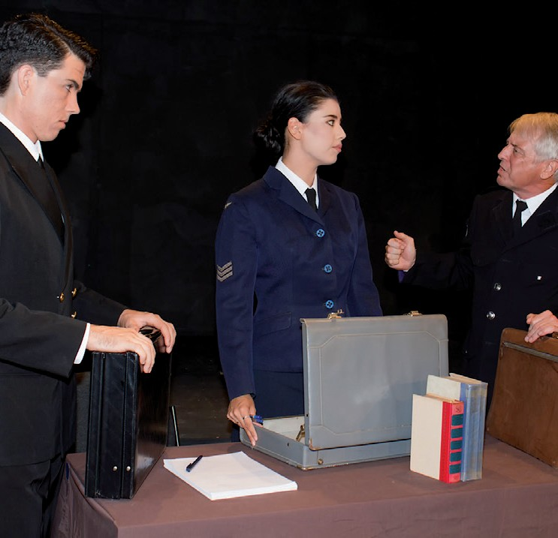 First Sat 10-2pm Conservatorium
Kendrick (in sunglasses) with platoon leaders ordering them not to perform a disciplinary action known as a “Code Red” Photo: Lyn Gale
Daniel Kaffee (Dylan Wheeler), Jo Galloway (Mel Strawbridge), Sam Weinberg (GraemeSpeed) Photo: Lyn Gale

RURAL FIRE SERVICE NEWS WITH MIKE BERRY
O

ur Captain Ross McDougall has left the area (hopefully not permanently) to trial a move
back to his North Queensland home. Ross has done an outstanding job for the Dunoon RFS over the past 20 years, serving in numerous roles including Captain for at least the past 10 years.
Ross’s departure has left a huge hole in our brigade that will be very difficult to fill but our members stand ready to con- tinue to provide this vital emergency service for our community. We do want to acknowledge and thank Ross for his committed service over many years.

Winter Preparations
Winter is on its way and this is a time of year when the Fire Service see a spike in house and other structure-related fires. Smoke alarms are a critical early warning to a potential disaster so it is important to make sure you have them installed and they are in good working order. Now is the time to check your smoke alarms are operating correctly and replace batteries if necessary. It could just save your life or that of a loved one.
Chimneys can be a potential fire hazard if not checked and cleaned before first lighting with the arrival of cooler weather. Now is the time to have your chimney checked and cleaned so you are ready to go once wintery weather arrives. Also checking the operation of other equipment such as heaters and electric blankets is important at this time of year.

Fire Hydrants
The Dunoon Fire Brigade did a spot check on a number of fire hydrants around Dunoon in recent weeks and the results were somewhat disturbing. Some hydrants were difficult to find, some were hard to open and many were found to be full to the top with compacted red dirt once opened. A few could not be located at all because they are hidden in gardens or entirely covered by grass.
Fire hydrants are identified by the blue reflective marker located in the middle of the road with a yellow painted tri-
angle that points to the location the hydrant. Hydrants are mostly located on the nature strip or even inside the boundary of indi- vidual properties.
Hydrant lids are painted yellow and sometimes marked with a post with the letters HP (Hydrant Path) or HR (Hydrant Road) to indicate their lo- cation. Residents can play their part by keeping these essential water access points clearly visible for emergency service use if required.
It would be helpful if you could locate the nearest hydrant to your home or business premises and keep the lids clear of overgrowing gardens, grass, dirt, gravel etc that make them difficult to find, particularly at night. If you think you have the ability to open the lid and check to see if they are full of dirt that would be helpful as well. You could either remove the dirt yourself or if that is not possible then let the Fire Service know your hydrant needs attention. Hopefully neighbours can work together to check their nearest hydrant as often as possible.
We have contacted Council regarding our concerns and I am sure they will undertake some maintenance in coming weeks but this is an ongoing problem and residents can help by keeping clear and easy access to fire hydrants that are located near their property. The follow- ing link will provide more information https://www.fire.nsw.gov.au/page. php?id=9257

New Members
The Dunoon RFS are always looking for new members so if being part of this es- sential service has been something you would like to try please come along to give it a go. It can be hot and tiring work but the sense of achievement and standing within the community is very rewarding.
An initial introduction to what is in- volved can be provided at a local brigade level and if you decide it is something
you would like to pursue you can un- dertake the Basic Fire Fighter course that will allow you to attend incidents. After that you can simply remain a basic fire fighter or undertake a range of spe- cialist training courses such as Village/ Advance Fire Fighting, Breathing Ap- paratus, First Aid, Chainsaw Operator, Crew Leader, Air Support, Rural Fire Driver to name just a few.
We meet at the Fire Shed in Munro Road every Wednesday night from 7:00pm so simply come along or give Mike Berry a call on 0414 764360 to discuss. Don’t delay; act now, we need you.

End of Fire Danger Period
The Fire Danger period ended on 31/03/2018. Although permits are not required after this date please be aware you still have legal obligations for any fire you light.
You must advise the Northern Rivers Fire Control Centre on 66630000 and your neighbours at least 24 hours before you light up. Always be aware of fore- cast weather conditions – not just when you light a fire but also what may develop at any time your fire will be alight.
In an emergency call 000.
Mike Berry

Mini Excavator Bobcat Tipper
Rubbish Removal Yard Maintenance
Mowing Large & Small Handyman Work
Darren Bassey 0409 255 504
(02) 6628 2147

DUNOON & DISTRICT SPORTS & RECREATIONAL CLUB – www.dunoonclub.org.au

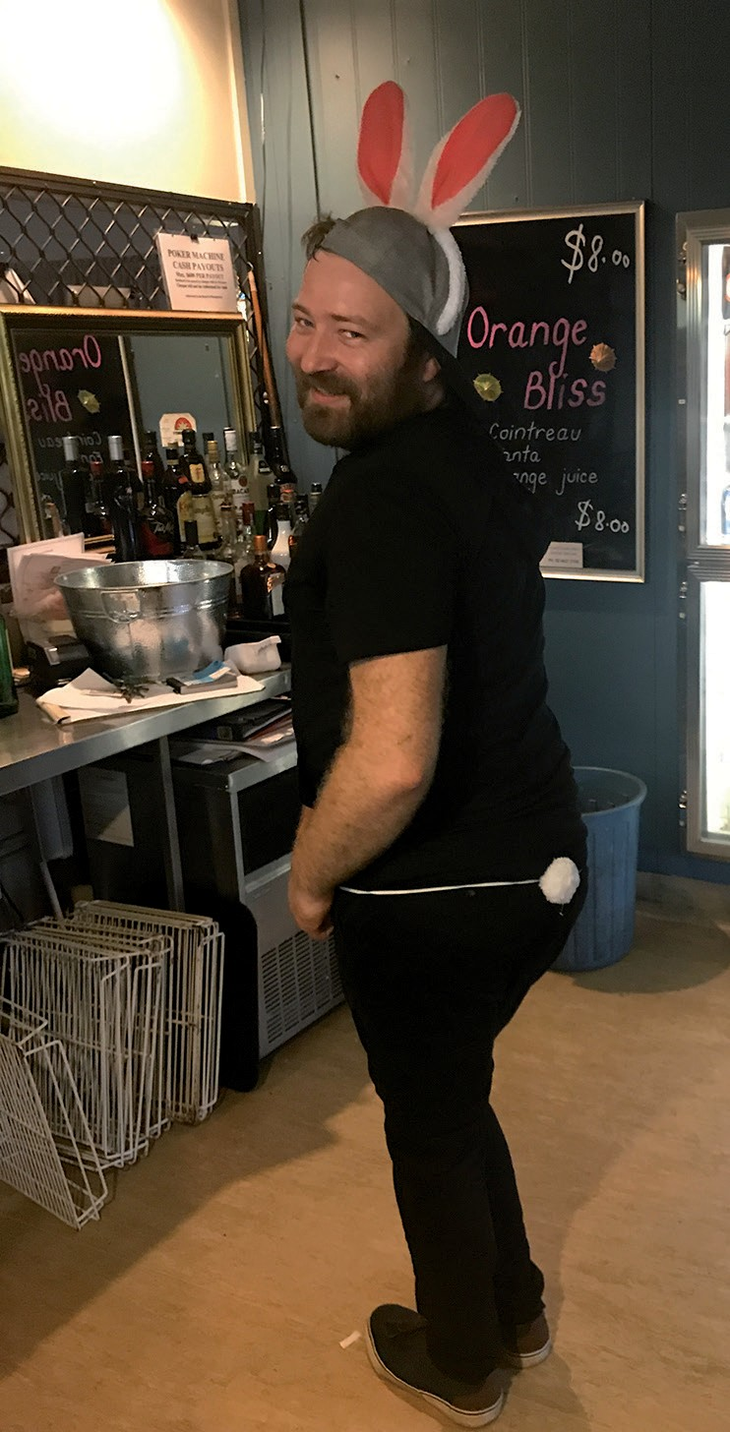ince mid 2017 Andrew Hicks and I have been running Thursday night raffles at the Club to raise enough money to buy a P.A. system. For those who don’t understand musician talk this is a complete sound system including amplifiers, speakers, microphones, etc. To date we have raised about $1800.
Andrew – the Easter Bunny
S
I am pleased to say that we have just purchased the first component in the system – a 16 channel mixing desk – at just under $700 delivered. Next will be two P. A.s – speaker and amplifier units.
Having this quality equipment will mean that visiting bands and musicians can possibly be hired at a lower cost and we will have a decent microphone and speaker system for in-house announcements, badge draw, etc.
Thank you to all the people who have supported us by buying raffle tickets. We still have a little way to go but we are within sight of the end!
Annabelle Crow
PLUCKERS & POETS
2nd Sunday of each month Starting @ 3pm

FREE TRIVIA AND BINGO
Bingo 1st and 3rd, Trivia 2nd & 4th Wednesday of the month Starting @ 6:30pm

TRIVIA AFTERNOON
3rd Saturday of each month
Starting @ 3pm
THE DECK RESTAURANT OPENING HOURS
Until further notice, the club and restaurant will be open from 9am to 7pm on Sundays.
Weds 6-8pm Thurs 5-9pm Fri 6-9pm Sat 12-8pm Sun 9am-7pm
Meals including Pizza home delivery Weds only. Sunday lunch is a roast
For Club Bus information and bookings, please call 6689 5444
Friday Nights available for bookings thanks to Robert volunteering as Driver - call the club on 6689 5444
Otherwise only available for group booking. May be hired for excursions or attending events.

The Deck Restaurant
Wednesday 6-8pm Thursday 5-9pm Friday 6-9pm Saturday 12–8pm Sunday 9am-3pm
Pluckers and Poets every second Sunday of the month and weekend Seniors Soccer Games
Weekly Specials; Kids’ Menu; Vegan; Vegetarian; Gluten Free
We cater for functions, birthdays, corporate, high tea, weddings... any budget

6689 5444 / 6689 5469
Talk to Charlie or Jamie
Details are correct at time of printing

To confirm details phone Dunoon Sports Club 6689 5444

or visit the website
www.dunoonclub.org.au

Information for members and their guests
See you there!
4pm–7pm 4pm–7pm 4pm–9pm 4pm–10pm 3pm–11pm 1pm–9pm,
busy 3pm-7pm
Sunday
Club Opening Hours
Monday Tuesday Wednesday Thursday Friday Saturday
unless

DUNOON & DISTRICT SPORTS & RECREATIONAL CLUB – www.dunoonclub.org.au

THE DECK RESTAURANT
OPEN
The Deck Café is open every Saturday ( all day ) for award winning coffee, cake and breakfast too!

2nd Sunday of Month 3pm
Sing, dance, read, play – all welcome

PAPUA NEW GUINEA WITH CHARLES BETTERIDGE

EARTHQUAKES IN PAPUA NEW GUINEA 2018
I
n the February/March issue of the Dunoon Gazette my item covered an “Unstable Papua New Guinea
“ and on the 24th February the High- lands regions of PNG became very unstable indeed when 10 earthquakes struck on that same day. For many days after the Highlands area of PNG was continually struck by earthquakes .
During my time of working in PNG for thirty years 1960 – 1990 for Burns Philp/Ela Motors in many parts of the country I only experienced round twenty quakes in all those thirty years and most of them were up in the High- lands of PNG.
Mt Hagen 1966

I spent nearly four years in Mount Hagen (1979 – 1983), altitude 5,600 feet, as branch manager of Ela Motors and during that time I visited the Eastern, Western and Southern High- lands and saw for myself the rugged- ness and beauty of the country and nat- urally visited many villages at the same time. Yes, we felt a few quakes while up in the Highlands but there was only
minor damage to the villages and the roadways etc. – nothing like what has been happening now.

The road to Porgera in the Western Highlands of PNG. 1980

The quakes that have hit PNG in late February/early March this year (2018) up in the Highlands have been most unusual in the large number that have occurred in such a short time frame. I recently installed a computer pro- gramme of “Interactive Map of vol- canoes world wide and recent earth- quakes”. This map shows all the volcanic action going on (or at idle) plus all the earthquakes that are hap- pening around the world. There are several Geo Satellites in orbit picking up earthquakes and volcanic move- ments using UTC (United Time Clock time) and it shows the exact date, time, location, magnitude and depth of the quakes.

An earthquake would read for example, Sun, 4 Mar. 20:24.03 UTC, M4.9/10.0
km 114 km WSW of Mendi, Papua New Guinea. -6.4969/142.6661 USGS.
This translates as follows; Sunday, 4th March, 8.24 PM and 3 seconds
UTC time, Magnitude 4.9 and 10 km below earth surface, 114km West South West of Mendi, Papua New Guinea,
-6.4969/142.6661 (Longitude/Lati- tude), USGS (United States Geo Satel- lite).
When the quakes first started on Satur- day 24th February, I only wrote down on paper the days and dates and the number of quakes but not the mag- nitudes and location in PNG but by Tuesday 27th February I was able to download all the data. The print-outs showed not only PNG but every other country in the world and believe me I was quite stunned to see how many other earthquakes were going on in other parts of the world. Add to that the number of active (and inactive) volca- noes world wide (including PNG) and the fact that this is going on 24 hours a day – when I put it all together on my computer screen it shows how volatile earth is.

To put the full data of each quake would take many more pages but on average the quakes were around 10 km deep but there were a few “unusual” ones among them all. For instance: Tuesday 27 Feb. at just on midnight PNG time a 5.3 magnitude quake hit at surface level yet just 8 seconds later a magnitude 4.9
Ok Tedi Mine in 2001

OL90247

MVRL4739

PAPUA NEW GUINEA continued

struck 10 km deep and 11 minutes later another quake was 116 km deep!! 98% of the quakes were hitting the High- lands regions.
On Thursday 1st March two quakes hit the Saidor area in Madang Province just 5 seconds apart. The first quake was 111 km deep and the second 100 km deep.
During Monday 5th March only three quakes occurred, but on the very next day a total of 17 quakes occurred, one of which was a larger 6.7 quake which struck at about 13 minutes past midnight PNG time. That would have caused even more death and destruction to the Highlands areas. The big ques- tion is, what is next?
Is it possible that with all these earth- quakes happening in PNG they could set off some volcanic chain reactions? PNG has numerous volcanoes includ- ing a few up in the Highlands. Most of these are close to “The Ring of Fire”, a
giant tectonic plate that runs from Alas- ka’s western side, down past the west coast of the USA (where San Francisco is) then down past the west coast of South America and downwards towards the top of Papua New Guinea, then up past the Phillipines, Indonesia, Hong Kong, Japan and up past the east coast of Russia to near the North Pole. It is this huge tectonic plate moving now and then that causes these quakes.
From Saturday 24th February to 11th March (16 days) a total of 141 earthquakes struck Papua New Guinea ranging in magnitude from 4.7 to 7.6
Australia and New Zealand have sent cargo planes carrying food, water, medical supplies, tents, blankets etc.
Bistro Open 7 days Lunch 12pm -2pm
Dinner 6pm -9pm Mon - Sat 5.30pm - 8pm Sun
$10 lunch specials available
$10 Sunday Roasts
Member’s Happy Hour! Mon - Fri 3.30pm - 5.30pm
Wednesdays Free Trivia 7pm
Thursdays Kareoke with Mary Anne 9pm
Saturdays Live Bands 9.30pm
Saturdays: The One Nightclub opens

For all your specialist home theatre, phone, data, fibre and TV reception needs
Sales & service of Security Alarm & Camera systems
Call Iain Thompson
Phone: 0421 871 144
E-mail: wired4@iinet.net.au
New Zealand had also recorded 43 minor quakes in just two days on 11th and 12th March.
Yes, Papua New Guinea is a very vola- tile country especially when it comes to earthquakes and large volcanic erup- tions. Rabaul township for example sits inside a large volcanic caldera which is still active from time to time – but only minor, for now!
There is some information available on the extent of the damage in PNG and the humanitarian aid provided by Aus- tralia at http://dfat.gov.au/crisis-hub/ Pages/papua-new-guinea-earthquake. aspx
Charles Betteridge
Bistro Open 7 days Lunch 11:30am- 2:30pm
Dinner 6pm-9pm
Open all day from
11:30am-9pm Saturday and Sundays
$10 lunch specials available Mon-Sat
Happy Hour Mon-Fri 4-6pm Tuesday Musical Bingo from 8pm FreeTrivia Wednesdays from 7:30pm Live music every Sat night from 9:30pm Thurs-Steak Night & Karaoke Lounge
Nightclub open every Saturday from 9:30pm
We cater for functions Call us now to book
https://www.facebook.com/marygslismore www.marygs.com.au
Ph: (02) 6622 2924
Fx: (02) 6621 8040
email: info@marygs.com.au

Electrical Contractor Warren Lewis
Lic no 25239
Domestic - Commercial - Solar Rewires - Repairs
General Maintenance
24 hour service
Tel: 6689 5034
Mobile: 0428 539354
Give us a go!!!
Whian Whian Road, Whian Whian

J & J Ferronato
Lic No 217725C
QUALITY WORK
Renovations Extensions Decks
Contact John: 0429 895 130

Nik Hyde
Plumber & Drainer
New installations/Renovations Roofing/Guttering
Solar systems/Hot water services Septic Systems
Free estimates Commercial & Domestic 24hr Service
Dunoon 6689 5174
Mob: 0428 753 796

Facebook:http://facebook.com/marygilhooleys
Website: http://www.marygilhooleys.com.au
Tractor & Machinery Centre
30 Tweed St North Lismore 6622 2842
MacMaster Nut Harvesters

YOUR HEALTH

DO YOU WANT TO QUIT SMOKING?
In New South Wales, those who reside in outer regional, remote or very remote areas (19.9%) or inner regional locations (17.6%) have higher smoking rates than their counterparts who live in a major city (14.1%).
Dunoon is located in the Lismore Local Government Area and has a higher proportion of smokers (estimated
18.5 per every 100 people) compared to the national average of 16.1 per 100 people. Therefore it is important that smoking cessation services are provided to smokers residing in regional and remote areas and that’s what this study aims to achieve.
Real-time video communication, along with telephone support and written materials may be options that smokers are willing to use to assist them to quit or change their smoking habits.
Currently the Quitline offers telephone
support or written materials but does not offer people the option of receiving video support sessions delivered via platforms such as Skype or FaceTime. If this study finds that video support sessions assist smokers to quit then a video communication support strategy could be another option Quitlines offer as part of their services.
This study conducted Dr Tzelepis colleagues and from the University of Newcastle offers those in regional and remote areas, including Dunoon either video support sessions (via Skype, FaceTime or other form of video communication), telephone support calls or written materials to assist them to quit smoking or change their smoking habits. The study requires the completion of a 2 minute eligibility survey, a 10 minute baseline survey and a 4-, 7- and 13- month 10 minute follow up survey. Participants randomised to telephone or video support will also receive 4-6, 15 minute support calls.
For more information and to join
the study, Dunoon (and district)
residents can go to the website:
https://www.newcastle.edu.au/ research/quit
Cancer Council Australia’s Biggest Morning Tea
When: Official date is Thursday 24 May 2018 but you can register to host an event at any time from now until June
Who: For North Coast and Northern Rivers residents can register to host a morning tea and gather friends, family or colleagues to share a cuppa and show support to people affected by cancer
Register: Call 1300 65 65 85 or visit www.biggestmorningtea.com.au
Schirelle Domski
Cruise1st Australia 8985 9462
schirelle.domski@ cruise1st.com.au

www.cruise1st.com.au

LANDCARE WITH EMMA STONE

Water, Weeds and Wonder in Whian Whian
March 2018
There is a change in the air in Whian

Whian, and it smells rather good.
If you haven’t noticed it yet, all you need to do is follow your nose down to the Whian Whian Falls, and you’ll catch a whiff of freshly turned soil, with satisfying notes of decaying weeds and the heady flush of sap in the new growth of several hundred rainforest saplings.
You guessed it, Whian Whian Landcare
have been at it again.
This new Landcare site – visible from Whian Whian Road is just one compo- nent of a new project the group is cur- rently undertaking. ‘Healthy catchments and improved water quality in the upper Wilsons River catchment: Riparian and catchment restoration and soil conserva- tion in Whian Whian’ (the project) deliv- ers a comprehensive range of on-ground and community capacity building out- comes aimed at increasing riparian and catchment restoration, soil conserva- tion and community engagement in the Whian Whian locality of NSW.
Supported by North Coast Local Land Services with funding provided by the National Landcare Program and imple- mented in partnership with Richmond Landcare Inc, this project employs a combination of; on-ground vegetation restoration activities, soil conservation and erosion mitigation, water quality monitoring, and community capacity building activities to improve the health of the catchment and its people.
In 2017, Whian Whian Landcare got to- gether with the regional network group, Richmond Landcare, and dreamed up a project that ticked all the boxes. “We could see that poor water quality, de- clining riparian vegetation condition and soil erosion are priority issues for the Whian Whian area, so we wanted to build a project that would both address these issues, and engage and upskill the community while we were at it” said Whian Whian Landcare’s coordinator Emma Stone.

The Richmond Catchment received on overall ‘D+’ health rating in the 2014 ecohealth check, putting its health among the poorest in the state. The same report card delivered Rocky Creek (downstream of the sites) an overall rating of ‘B-’, with water quality at this site a ‘C’. Active restoration of riparian zone vegetation and reducing diffuse sources of fine sediments and associ- ated nutrients is identified as a long term action for improving the condition of the river system.
The latest activity of the project was a community tree planting event at the group’s new work site on land managed by project partner Rous County Council at Whian Whian Falls. With 24 people attending and 250 trees planted, the site will be the focus of the group’s work on public land for the next few years. The project also features a water quality monitoring program being con- ducted with Whian Whian and Dunoon schools; erosion control and soil conser- vation works on macadamia farms, edu- cational workshops for landholders, and on-ground restoration of riparian vege- tation condition on properties bordering Rocky and Branch Creek tributaries.
“The project has been a great success, due in no small part to the stellar efforts of the Whian Whian Landcare commit- tee and the willingness of committed

  
  □   


landholders. Whian Whian continues to punch above its weight as a local Landcare group, they really are leaders in our region” said Richmond Land- care Coordinator Hannah Rice-Hayes.
The next project activity will be a public event at a macadamia farm in May, ad- dressing erosion control. You can find out more about the project by following updates on the Whian Whian Landcare Facebook Page https://www.facebook. com/whianwhianlandcaregroup .
For more information contact: Hannah Rice-Hayes, Richmond Landcare Inc 02 6619 0115 landcare.support@ richmondlandcare.org or Emma Stone, Whian Whian Landcare, whi- anwhianlandcare@gmail.com

With generous support from NSW Local Land Services and the National Land- care Program:

ST. MATTHEW’S ANGLICAN CHURCH NEWS WITH ‘GINA MURRAY

What is happening at the Anglican Church of St.Matthew’s
After having January without services, we got the year off well with services as normal (10.00 am every Sunday) in February and on 25th February we had a combined service in Lismore before the Parish Annual General Meeting.
On the evening of March 2nd members of St Dympna’s Church and others joined us in St Matthew’s to present ‘The World Day of Prayer’ Service.
The World Day of Prayer is a worldwide movement dating back to the 19th Century which brings together Christian traditions for an annual day of worship and prayer. On the first Friday in March each year more than three million people (including our few in Dunoon) in over 170 countries join in a service prepared by the WDP Committee of a different country to celebrate both our unity in Christ and our diversity in culture.
This year, the Service had been prepared by the World Day of Prayer Committee of Suriname. We learned about the plight of women and children in Suriname and we were told us some facts and given information about how Christianity has been able to strengthen the resolve of the people there. It was a very informing and interesting service.
The money given that evening in Collection has been forwarded to The World Day of Prayer Committee. The World Day of Prayer, Australia
From BIG earthmoving tyres to a small wheelbarrow- we do them all!
We’re agents for:
offerings are used to provide grants to various women and children’s programmes. Each country’s committee is responsible for determining the use of the offering as it relates to the theme for each year.
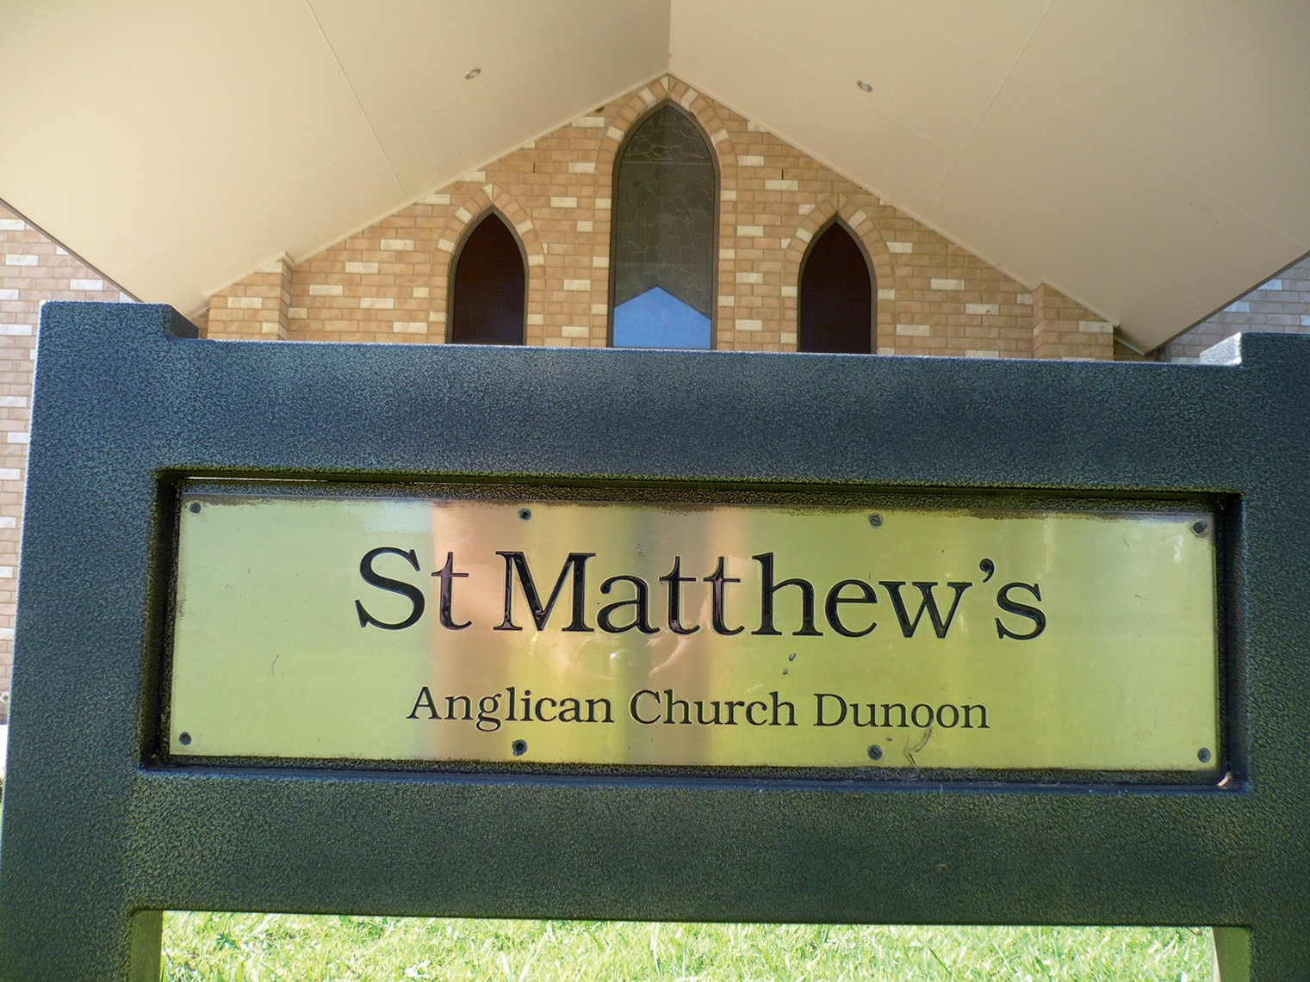
The supper
afterwards was to our normal standard and the fellowship as
well as the good tucker made for a very interesting conclusion to the evening.
Some members of St Matthew’s formed a lenten study group which met every Thursday evening during Lent. The programme was based on the movie ‘The King’s Speech’ and it was very thought provoking. It will, hopefully, be very valuable to those who took part.
The group will re-convene after Easter and continue their study of ‘Revelations’ on Thursday evenings at 7:00pm in the Church.
We held our Anglican Women’s Guild Annual General Meeting at the

EUCHRE
Note new time 7:00 pm
ANGLICAN CHURCH UNDERCROFT
Thursday evening at 7.00pm Call Charles 6628 2064

beginning of March. Needless to say, all the office bearers stayed the same and we continue on doing the best for our beautiful church
Don’t forget, normal services are every Sunday at 10.00am and Guild meets every three months.
Love to see you at Church sometime!
‘Gina Murray, Anglican Women’s Guild of St. Matthew’s, Dunoon
NEW MEMBERS!
WEDNESDAY
COMMUNITY GROUP
Temporarily being held in the
ANGLICAN CHURCH UNDERCROFT
Wednesday morning at 10am
for morning tea and craft activities.
Call Ron 6689 5018

30 Union Street South Lismore Phone: 6621 3561
PIRLOS TYRE CENTRE

ON FARM SERVICE - ESTABLISHED 25 YEARS - LOCALLY OWNED

WILDLIFE INFORMATION, RESCUE AND EDUCATION SERVICE NEWS

Wires needs more members in the Dunoon area
With such rich biodiversity in the Dunoon area, WIRES is regularly re- ceiving calls about injured or orphaned birds and animals – like this Eastern Whipbird chick that was rescued from Dunoon earlier in the year. It was taken into care for 24 hours to ensure it was well and hydrated before being returned to its family the following day.
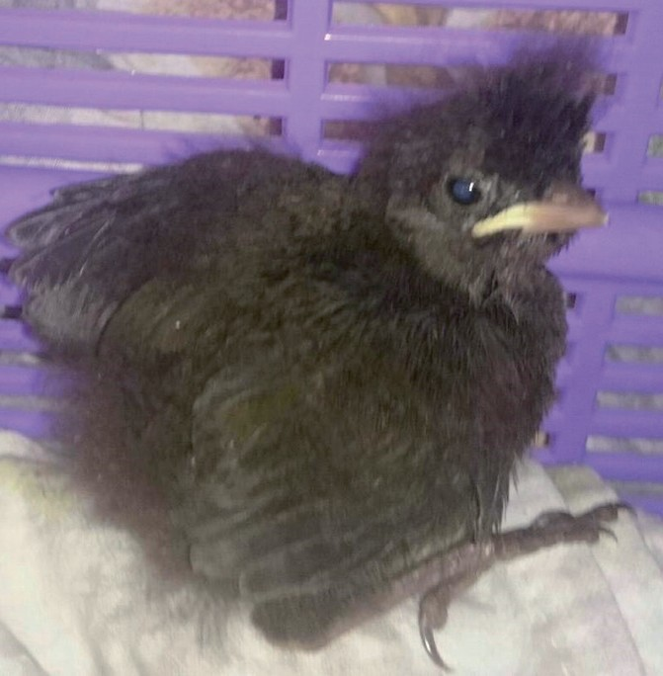
One of the delights of being a wild- life carer is reuniting chicks with their parents. In this case, this cute little chick’s mum, dad and a sibling were skipping around in the bushy under- growth and
making their wonderful whip noise. It was a very happy reunite for the WIRES bird carer.
In March, this Mountain Brushtail possum, now named Rocket, was found all alone on the side of the road at Dunoon. Weighing just 230g, she is now in care with one of WIRES specialist possum carers.

Delightful as it is to rescue and care for birds, possums and gliders, macro- pods (kangaroos and wallabies), small mammals, echidnas and reptiles, not everyone has the time or space to take on caring roles. However, there are
many valuable ways you can help.
WIRES makes the most of its members’ skills and interests in roles as diverse as administration, sewing, building and catering, fundraising and education ac- tivities with schools and community groups. In the Northern Rivers some WIRES members answer calls from the public via our 24-7 Hotline. Volunteer- ing for 2-4 hours a week is a great way of contributing from the comfort of your own home.
You can start training to become a WIRES member AT ANY TIME with the WIRES Rescue & Immediate Care Course. You can commence the online (or booklet) course at any time and then sign up for a face-to-face practical workshop, next held in Lismore on May 27th and September 23rd.
Give us a call on 66281898 for more information about what being a WIRES member is like, and how you can join and contribute. You can also find out more at https://www.wires.org.au/ rescue/Become-a-rescuer

Small Mammals
Have you seen a “mouse”? Disturbed a “rat”? Don’t assume that the animal is a feral pest. There are numerous small Australian mammals which can be easily mistaken for rats and mice, and they often are friends rather than foes.
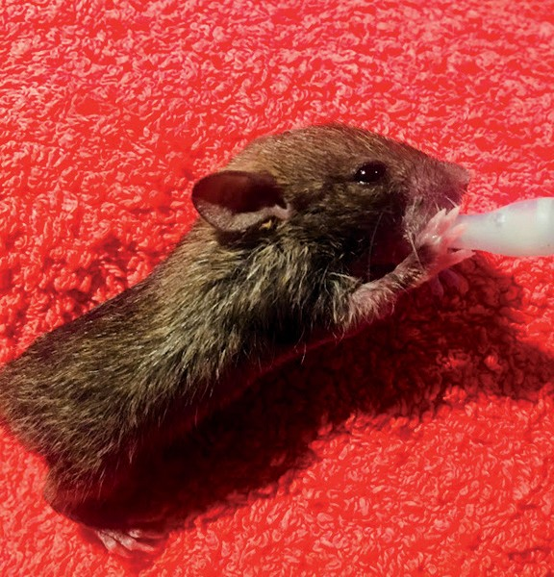
For example, this melomys which has only just opened its eyes, is some- times known as a mosaic- tailed rat, and is an Australian native rodent.
There are a number of species in the Northern Rivers, including the Grass- lands and the Fawn-footed melomys.
The native Bush rat lives in eucalypt and rainforests and eats insects, fungi, seeds roots and plant stems. In the North- ern Rivers we also have the Swamp rat and the Water rat. These shy creatures rarely move in to human houses, but are
sometimes found around sheds and rural properties. The New Holland mouse (listed as vulnerable) is similar to the introduced House mouse but does not have a pungent odour.
We also have a number of species of An- techinus in Northern NSW; the Brown, Dusky and Yellow-footed as well as the Black-tailed antechinus that was first discovered in the Border Ranges in 2014. Together with Planigales (which are listed as vulnerable to extinction), these small marsupials are often mistak- en for mice. Being carnivores, they eat insects such as cockroaches, so are great inhabitants around your house.
It can be difficult to identify these species of small mammals, particularly when they are young. Please be careful when dealing with mice and rats around your home as you could be accidentally killing protected native wildlife.

A very different echidna bin
People are often surprised to know that echidnas are very good climbers. With each spine controlled by a separate muscle they can scale fences and push their way past many obstacles. Wildlife carers need special, deep tubs and en- closures when they rescue or care for an echidna so that they don’t escape.
When WIRES received a call from Peter at Dalwood they discovered an echidna that had definitely met its match. An echidna had fallen several metres down into a Macadamia hopper and definitely could not get out.
The WIRES rescuer climbed down a ladder into the macadamia bin to wrestle with this strong animal and carry it back up the top (see photo on front page).
The echidna is very lucky to have been spotted by Peter and to have survived the ordeal. It should make a speedy re- covery before being returned to its home on the macadamia farm.
Contact WIRES for rescues, advice or enquiries. The 24-hour hotline is for all calls to WIRES in the Northern Rivers - 6628 1898. www.wiresnr.org

VISIT TO CISARUA – A PERSONAL REFLECTION WITH KAY DOUST
A

personal reflection on a visit to Cisarua with Mozhgan Moaref and friends from Refugees and Asylum Seekers Infor- mation Centre. 31st January 2018.
Today I visited some families living in the Cisarua Refugee community. It was both a joyful and disturbing experience.
We arrive in Bogor in the hallmark heavy traffic of Jakarta and environs. We are here to deliver the monthly care packages for the families. The packages contain items for personal hygiene and are tailored to men, women and children individually. Mozhgan purchases items from donations received. Mozhgan observes that skin conditions have re- solved considerably after the introduc- tion of the care packages.
Cisarua is a small town nestled in the mountainous region above Bogor, outside Jakarta. Locals tell me it rains every day and the damp conditions create mould problems in the houses here. The air is slightly cooler and less humid than Jakarta.
The first house we visit is a simple home with two main living areas, around 4 bedrooms and a small kitchen area. There are a couple of simple bathrooms. The tenants have to pay a yearly rental equivalent to $4000 AUD along with a payment of $1100 AUD to local authori- ties to be able to live there.
We are warmly welcomed. Mozhgan is clearly respected by the people in the home. The household is dominated by women. Most of the women are Hazaras from Afghanistan and several Ethio- pian women. The household has just welcomed two young Ethiopian girls who had nowhere to go and no support. The eldest is 21, she has her 16 year old sister with her. They are unaccom- panied. The Ethiopian women speak Arabic or Oromo language. The Hazara women speak or understand Farsi or Dari language. One of the Hazara family groups have their brother with them. Mozhgan tells me there have been some problems as he tried to assert au- thority over his sisters as is the custom in Afghan society. His sisters resisted.
There is one married couple living there. The husband is our guide, he is warm and open. He was a me- chanical engineer in Afghanistan. His wife can move freely un- accompanied in the community. There is a relaxed and happy mood in the home with laughter and coopera- tion.
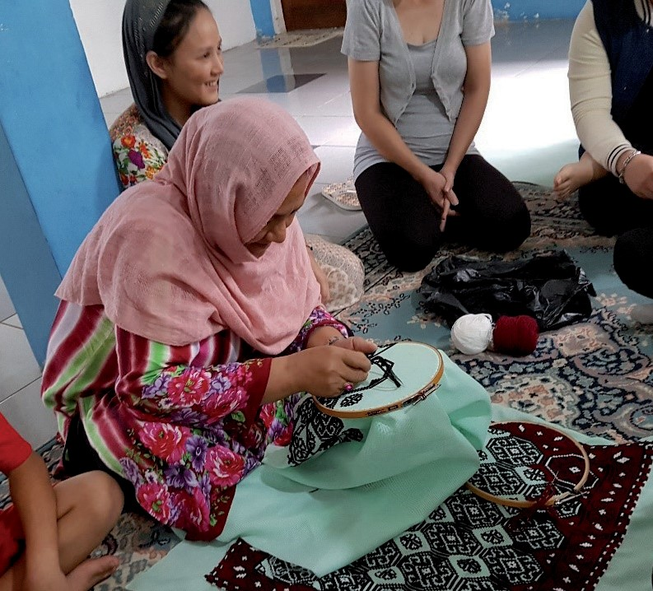It hasn’t always been this way. When the group started to live together each family group kept to them- selves, did not mix or share resources. Mozh-
A Hazara woman embroidering a traditional afghan pattern
gan’s mother has been a positive influ- ence and an agent for change. A refugee herself, she regularly spends time in the household, bringing a lifeline of gro- ceries weekly that she and Mohammad purchase in Cisarua and distribute, only made possible by donors in Jakarta. She talks with the families and teaches sewing and quilt-making. Mozhgan and her family are remarkable.
Some of the Hazara women make beau- tifully embroidered cushions, the in- tricate patterns all from memory. The women have all worked hard to prepare a feast. We sit on rugs on the floor and share a delicious Hazara meal. Freshly made yoghurt, delicious chicken and vegetables in a delicious sauce, fresh tomato and cucumber, rice and flat bread.
Patrick, a volunteer local GP does health checks and writes prescriptions if required.
We make our farewells and drive to another area in Cisarua. On the way Mohammed, Mozhgan’s brother stops at a house to deliver CARE packages but we can’t visit there as one of the children has contracted hepatitis and tu- berculosis.
We walk down the tiny laneways through puddles and past open drains. There is still water everywhere. We

meet a family living in a tiny room ap- proximately 3m x 4m. It is neat and tidy. There is a boy around 8 and a girl around 6 and they have a little sister who is 6 months old. She was born on the floor of the room, her mother was unattended during the birth. The chil- dren look healthy and their mother is engaged and charming.
The father’s anguish is palpable. He doesn’t smile, he seems tired and far away. He answers questions politely but I can see this is difficult. His gracious wife makes sweet fragrant cardamom tea. She seems to genuinely enjoy the company. I ask whether the children go to school at the refugee learning centre but they cannot afford the regis- tration fee and the waiting list is long. The family fled Kabul and increasing

The LIFELINE SHOP @
Casino St South Lismore Open 9.30am–4.15pm MON–FRI
9am–Noon SAT

THOUSANDS of BOOKS @
GREAT prices!
HEAPS of RECYCLED
CLOTHING @ bargain prices!
Furniture Warehouse 8.30am– 4.30pm weekdays & Sat 9am– midday
23 Three Chain Road, Lismore

VISIT TO CISARUA – A PERSONAL REFLECTION continued

violence. They paid $4500 each to the people smugglers, they sold everything. The smugglers said they would be sup- ported during the “three weeks or so re- settlement” process in Indonesia. They were promised heaven and delivered hell. They have no money, friends have banded together to rent the small room for them, there is nothing to do and no education for the children. They have been in Indonesia six months.
We thank the family and move on, as we walk by another couple invite us in to their home also but we have two more visits planned and must keep going.
We greet another Hazara family who have been here around 11 months. There is a husband and wife and little girl around 2 years old. The child has been unwell so Patrick checks her over.
The family fled a regional city near Kabul. They have always experienced discrimination. The Taliban says that killing one hazara is worth seven others and a pass into heaven. They sold eve- rything to leave. A short time later the borders closed and their friends who couldn’t get out have been killed.
There is no going back. A visitor paid their rent for the month but like the other families there is nothing left and they must rely on others for their exist- ence. The husband patiently answers questions while the wife listens from the bedroom doorway. He was a teacher and delivery driver. He has the same empty resignation we saw in the last home. He smiles weakly and Mozhgan tells me the family had no food for days and finally
rang in desperation for help last week; he was deeply ashamed. We ask if we can have a photo, the wife asks her hus- band’s permission. She is not permitted to leave the immediate village. The wife bids me fare- well, smiles, holds my hand and says to me ‘’mother’’ in solidarity with her.
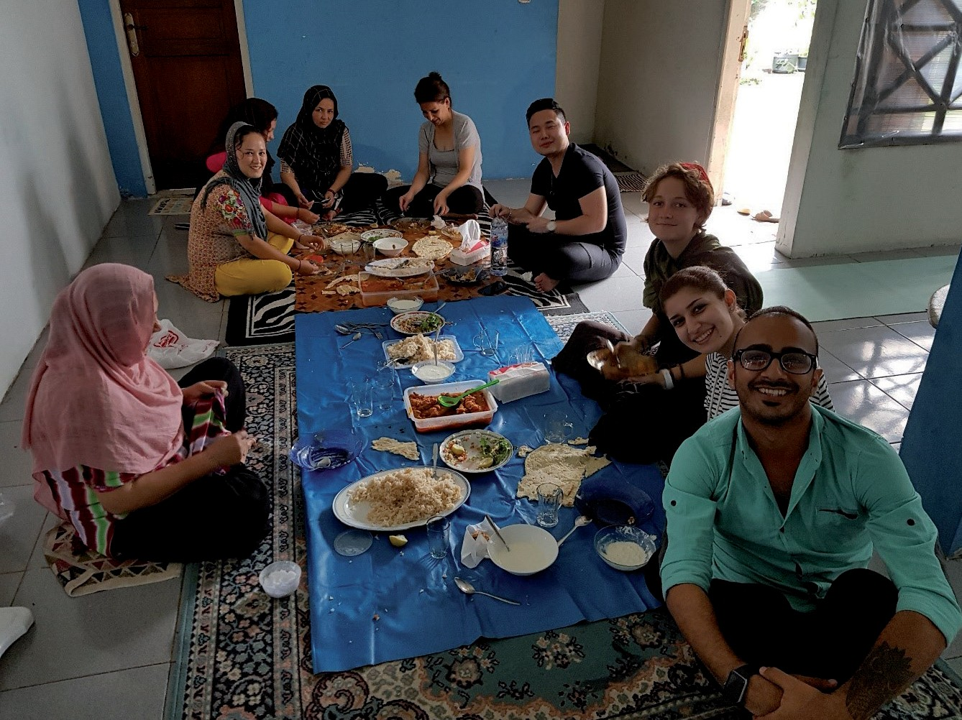We move on to our final visit. We climb a pre- cariously steep flight of

Hazara hospitality
stairs to the small upstairs apartment with two bedrooms. The family are not Hazara but another ethnic minor- ity. They fled Kabul with the increas- ing bombings and violence. They are Shia and not considered muslims by the Taliban. They paid $19,000 to escape with the same promise for quick reset- tlement and support in the interim.
The husband is outgoing and person- able, he is a good language scholar. He comes from a family of rugmakers. His wife is shy, she greets us, then makes herself scarce.
There are three boys in the family, the two younger children attend the local refugee learning centre and are excel- lent students. They
dream of becoming a pilot and a doctor. Father motions me to the older child in the bedroom. He lies on a mattress, his eyes track involuntarily and he grasps my hand when I offer it. He makes un- intelligible sounds. In Kabul he was nearby when a suicide bomber exploded. He was in a coma for 3 days and woke up this way. He was also a bright student, now he suffers incontinence and sei- zures. His family brought him with them from Kabul. His medi-
Star students of the refugee learning centre and Lotus, an Australian intern.
cation is paid for by a buddhist organi- zation. The wife constantly cares for the family and disabled child and she is experiencing foot problems. Her life is constrained within the walls of the apartment. She brings us tea and sweets and slips back into the kitchen.
There is no agency for any of these fam- ilies, only utter dependency. Forbidden to work with no access to any unpaid medical care or education support. There is a world weariness amongst the men and a meekness amongst some of the women. Their situations are unsus- tainable.
Mozhgan believes it is the basic simple things that combine to make a difference to their lives, the things we all take for granted; she works hard to bring some normality to day to day life.
The tragedy of the situation is the utter waste of these lives. From my perspec- tive, as an outsider it feels as though the world has forgotten these people or perhaps they are just invisible. Hidden away amongst the alleys and lanes, they barely exist.
Kay Doust
To find out more, or ways to donate,
visite www.raicindonesia.org

VILLAGE HALLS
SPORTS AND GROUPS
FIRE PERMIT OFFICERS

DUNOON HALL
Channon/Dunoon Pony Club
Fiona Wilders

6628 2690
DUNOON
Barry Watts 6689 5359

Channon Tennis Club 6688 6165
Wednesday 10 am Ron
Community Group 6689 5018
Thursday 5:30 pm Mark Roberts Exercise Class 0419 831 424 Mon and Wed 9 am
Lifestyle Mgmt
6 weekly 6:30 pm Mark Roberts
Film Night 0419 831 424

Sunday 9:30 am Christadelphi-
Sunday School ans
Sunday 11 am Ray Patch
Church Service 6689 5229

Community members welcome. For all bookings please contact: Dunoon Post Office 6689 5101

Aline Feebrey 6689 5438

Dunoon Sports Club Enquiries & Cricket
Dunoon Social Golf
Chris Gulliver
Dunoon United Football Club
Rob Gatt (President) Matt Hill (Secretary)
DunoonTennis
6689 5444

6689 5147
0428 428 165

0428884222
0438509284

TULLERA
John Hildebrand 0408 282 224
John Mace 0415 499 929
THE CHANNON
John Hutchison 6688 6480

Pauline Leeson
Call Sports Club 6689 5444 | Tony Roden | 6689 1562
Tullera Tennis Club 6628 2224 | Neale Hayter | 6688 6171
Girl Guides | J.J. Bruce | 6688 6453
Helen Hargreaves 6618 9169 | Russell Johnston | 6688 6185
BUS TIME TABLES | ROSEBANK  De Condos | 6688 2163

Tullera Hall 6628 2060
Corndale Hall David Hunter
6628 4364
HALLS BUS COMPANY
WHIAN WHIAN – LISMORE
School Days Only School Bus Service
Please flag driver / 0421 566 460
Dave Hughes 6688 2023
Eric Kinchin 6688 2217

WILDLIFE CARERS

Dorroughby Hall 6689 5013
DEPARTS Whian Whian (cnr Starkey
Rd)

7:57am

Whian Whian Hall Trevor Tuckey
0417119142
The Channon Hall General Store
6688 6240
May St, Dunoon (Nthn end) 8:08am
May St, Dunoon (Sthn end) 8:10am
ARRIVES Trinity 8:40am
Lismore Square - Brewster

CHURCH SERVICES
DEPARTS
St (opp taxi & bus zone) 3:18pm
Trinity Bay 1 (opp Menins) 3:30pm

Northern Rivers Wildlife Carers 6628 1866

DUNOON ANGLICAN
Holy Communion Every Sunday 10.00 am
Guild meets first Sunday of month 11:30 am
CHRISTADELPHIAN ECCLESIA
Sunday School 9.30am Memorial Meeting 11am each Sunday Bible Address on occasions 6689 5229
DUNOON CATHOLIC CHURCH
8.30am every Sunday morning
GOOLMANGAR CATHOLIC CHURCH
2nd & 4th Sundays 9.30am

COMMUNITY MARKETS
TUESDAY Lismore Organic Market Every Tuesday 7:30 – 11 am Lismore Showgrounds
EVERY SATURDAY Lismore Farmers’ Market
8am Lismore Showgrounds
Alstonville Farmers’ Market
8am – 12 noon Bugden Lane Car Park
ARRIVES Dunoon Shop 4:00pm
Whian Whian 4:15pm

DUNOON BUS SERVICE
Wheelchair Accessible
6624 8734/0412 248 503
Service is ‘Hail & Ride’ along the route
Bus For Hire
DURING SCHOOL TERM:
DEPARTS Dorroughby Hall 7:50am
Dunoon Store 8:00
Modanville Store 8:10
Tullera Hall 8:16
Minschull Cres. 8:21
R.R High school 8:25
Woodlark St 8:30
Lismore Square 8:32
Trinity interchange 8:35 Bay 10

WIRES Animal Rescue 24hr Hotline
6628 1898

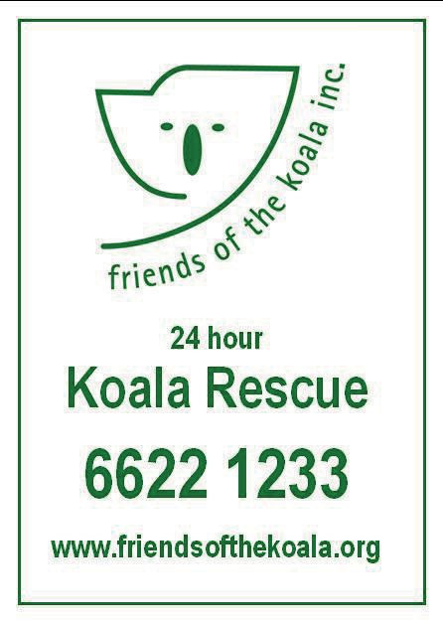

MOBILE LIBRARY
Feb 6 and 20

1ST SATURDAY Lismore Makers Market
10am – 2pm Cnr Keen and Magellan
1ST SUNDAY Lismore Car Boot
8am – 2pm Lismore Square Carpark
Byron Bay Market
DEPARTS Lismore Bus Terminus 3:30pm
Lismore Library 3:33
Trinity interchange 3:37 Bay 10
DURING SCHOOL HOLIDAYS:
Tuesday Week 2 Michael Riddle Enquiries: Phone 6625 5100
Mar 6 and 20
Apr 3 and 17
May 1, 15 and 29
Jun 12 and 26

2ND SUNDAY The Channon Craft Markets
http://thechannonmarket.org.au/
3RD SATURDAY Mullumbimby Market
http://www.mullummarkets.com.au/
3RD SUNDAY Lismore Car Boot Bangalow Market
DEPARTS Dorroughby 8:30am Dunoon 8:40
Modanville 8:45
Tullera 8:52
Minschull 8:56
Clunes 9–10am School
Dunoon 11:15am–12:15pm School
Modanville 2:00–3:30pm School

OTHER USEFUL NUMBERS
Dunoon Lodge

4TH SUNDAY
9am – 3pm http://www.bangalowmarket.com.au/
Nimbin Markets
Woodlark 9:00
Lismore Bus Terminus 9:07
DEPARTS Lismore Bus Terminus 3:30pm
Gordon Starkey 6689 5166
Northern Rivers

4th and 5th Sunday 8am – 4pm Market coordinator 0458 506 000
Lismore Library 3.33
Animal Shelter Robyn
6681 1860

LOCAL BUSINESS PHONE DIRECTORY
SCHOOLS PRESCHOOLS PLAYGROUPS
Dunoon Public School | 6689 5208
Modanville Public School | 6628 2234
Corndale Public School | 6628 4305
The Channon Public School | 6688 6236
Whian Whian Public School | 6689 5240
Dunoon Pre School | 6689 5396
The Channon Children’s Centre | 6688 6330
Dunoon After School/Vacation Care | 6689 5930
Tullera/Modanville Playgroup | 6689 5381

Advertising | Dunoon Gazette | 6689 5954
Aged Care & Respite | Nimbin Aged Care & Respite | 6689 1709
Bottle Shop | Dunoon General Store | 6689 5225
 | Mary G’s | 6622 2924
Bus Service | Dunoon | 6624 8734
 | Whian Whian | 0421 566 460
Carpenter | John Ferronato | 0429 895 130
Celebrant | Gina Murray | 6689 5104
Childcare | Northern Rivers Family Day Care | 6621 6437
Doctor | Dunoon General Practice, James St | 6689 5811
0457 895 414

>>> Ph 66 895 396 >>> 84 James Street, Dunoon
>>> info@dunoonpreschool.com >>> www.dunoonpreschool.com
Earthmoving | Tom Thumb – Jeremy | 6689 5414
 | Dugright – Michael | 0412 230 982
Electrical Services | Warren Lewis, Whian Whian | 6689 5034
Fencing Contractor/ | Andrew Shepherd | 0431 095 583
Firewood
General Store | Dunoon General Store | 6689 5225
Holiday house | Dianne Flynn (Port Macquarie) | 0408 614 113
Insurance | Dudgeon & Berry, 5/76 Woodlark St | 6621 3000
Laundry Service | Clean & Green Laundry, 50 Terania St | 6622 1359
Plumber | Nik Hyde | 6689 5174  0428753796
Postal and Services | Dunoon Post Office – Fiona | 6689 5101
Refrigeration | Russell’s Refrigeration | 6621 3992
Restaurant | Dunoon Sports Club, Cowley Rd, | 6689 5469
 | Mary G’s, Cnr Woodlark/Keen St | 6622 2924
Septic Tank Pumping | Summerland Environmental | 6687 2880
Sports Club | Dunoon Sports Club | 6689 5444
Takeaway | Modanville Takeaway | 6628 2005
Tipper/Handyman | Darren Bassey | 6628 2147
Towing Service | Bruno Zambelli, OL90247,Modanville | 6628 2230
 | Lismore Tractor & Machinery Centre, 30
 | Tweed St, Nth Lismore
Transport | Northern Rivers Community Transport | 6628 8806
Travel | Schirelle Domski Cruise1st Australia | 8985 9462
Tyres | Pirlos, 30 Union St, Sth Lismore | 6621 3561
Wine | Imogen’s Farm Wines | 0411 518 096
Wired4 – Home Theatre | Iain Thompson | 0421 871 144

Tractor Repairs 6622 2842
VOLUNTEERING I CAN DO THAT!
Want to meet new people?
Learn new skills?
Participate in your community? VOLUNTEERING IS FORYOU!
Volunteering is fun, easy and accessible to
everyone.
Be part of your community, make new friends, be appreciated and feel good about yourself.
The Northern Rivers Community Gateway Volunteer Resource Centre is here to make volunteering easy.
Call NRCG VRC 6621 7397
Email vrc@lnci.org.au

Socialise  Relax  Connect  Share 
We offer all seniors, people with a disability and all carers in our local communities opportunities to socialise
DISCLAIMER
The opinions expressed in this newspaper and on its website are those of the individual contributors and are not necessarily those of the Gazette editor or staff. Contributors are asked to ensure they have copyright permission for materials submitted. Contributions are reproduced in good faith and the Editor or staff cannot be held liable for any inadvertant breach of copyright.
Copyright Dunoon and District Gazette If you wish to
reproduce an article, please request permission by e-mail.
Please be aware that if you are attending public functions, your photograph maybe taken and submitted to the Gazette for publication in print and on the website. If you do not wish for your photo, or photos of members of your family to be published, pleas get in touch, with complete confidentiality, with the Editor via e-mail or phone – details on Pg 2.

and take a break. Phone for more information
Tel: 6689 1709

Social groups in Dunoon, The Channon, Koonorigan and Nimbin, monthly bus trips, home visits, events and
celebrations, free computer & internet access in Nimbin

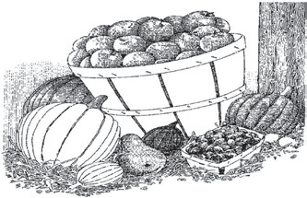
HOT PIE & COKE
TOFU PRODUCTS
GLUTEN FREE PRODUCTS
ORGANIC HEALTH FOODS
FRESH MEATS FROM HUTLEY BROS.
LOCAL BUTCHERS
88 JAMES STREET, DUNOON TEL: 6689 5225
OPEN 7 DAYS MON – SAT 7AM – 7PM
SUNDAYS AND PUBLIC HOLIDAYS 8AM – 6PM
BREAD, MILK & DAIRY
BOTTLE SHOP
TOP VARIETIES OF WINES AND BEERS
NEW! SANDWICHES AVAILABLE BY PRE-ORDER $4.50 EACH ORDER BY 10:30AM
YOUR LOCAL STORE FOR FAMILY FRIENDLY SERVICE
DUNOON GENERAL STORE
COFFEE & CAKE

www.channondunoonponyclub. pcansw.org.au
THE CHANNON /
RURAL FENCING CONTRACTOR
NEW! – SPLIT FIREWOOD
DELIVERY AVAILABLE FOR FIREWOOD

Free quotes on new fences and repairs Fully insured

4 WHEEL DRIVE TRACTOR & TIPPER ;
HYDRAULIC POST DRIVER AND POST HOLE BORER
CALL ANDREW 6688 6364,
MOB: 0431 095 583

Septic Tank Pumping

and specialists in all liquid waste collection and processing
Call for more information or a quote

DUNOON PONY CLUB
For further details please contact: Fiona Wilders Club President Hm: 6628 2690 Lisa McFadyen Vice President Hm: 6629 1023 Mykaella Gosper Club Secretary Hm: 6629 3486 Irene Brockhill Treasurer Hm: 6686 4798
Dunoon General Practice
100 James Street, Dunoon
Dr. Nathan Kesteven
Surgery open Monday, Tuesday,Thursday and Fridays from 9am (subject to change)
Phone: 6689 5811 Fax: 6689 5833
Bulk billing available
SUBSCRIBE TO THE GAZETTE E-MAIL
LIST at www.dunoongazette.com

